p.varunteja

2403A52138

write a python program to check whether a string is palindrome or not code:

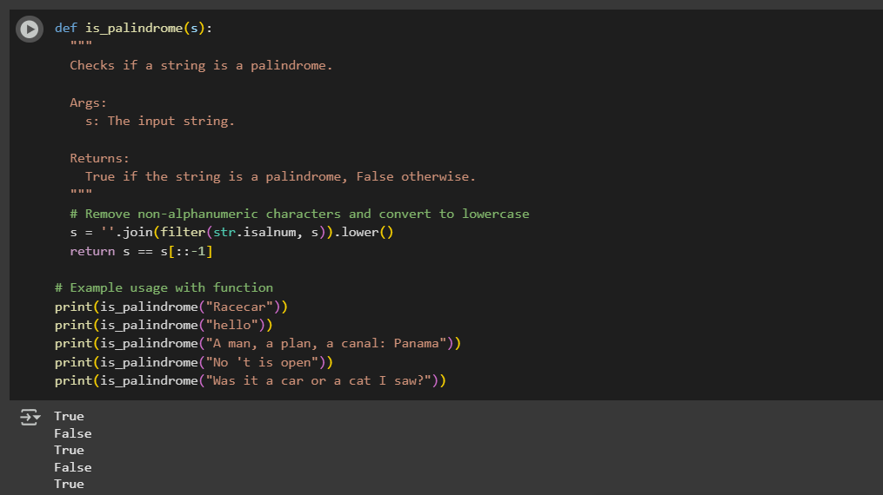

Explanation :

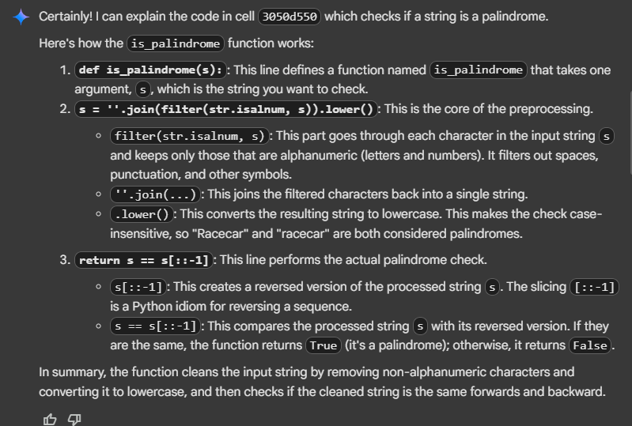

generate a program thet find the largest and smallest numbers in a user provided list code:

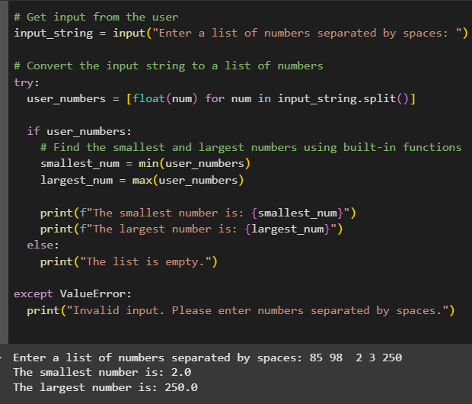

Explanation :

